Nama : Siti Fauziyah

NIM : 18090019

Kelas : 5B

**Laporan Pratikum 5**

1. Source Code

MatakuliahValidation.php → controllers

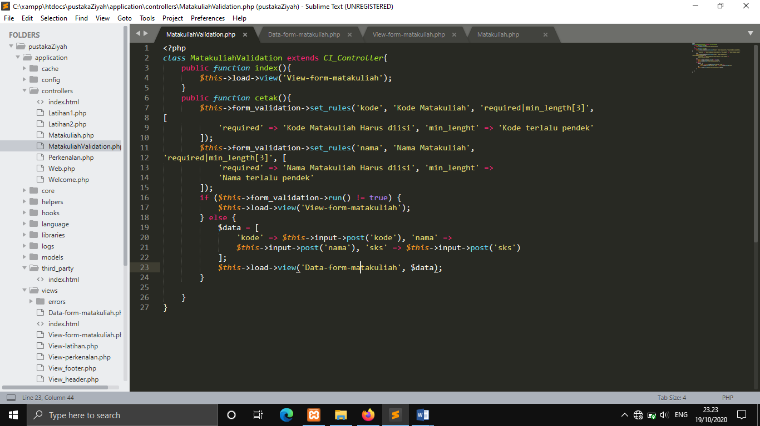

View-form-matakuliah.php → views

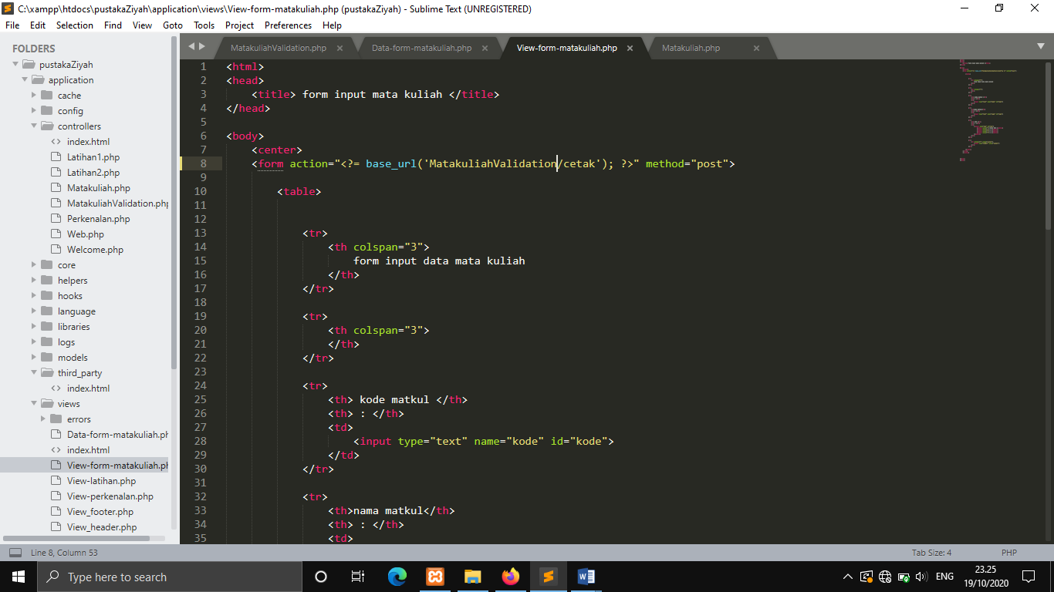

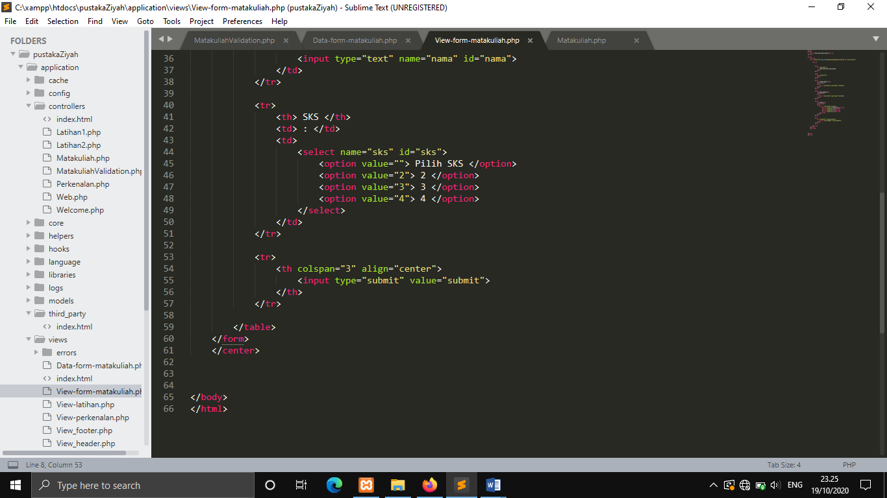

Data-form-matakuliah.php → views

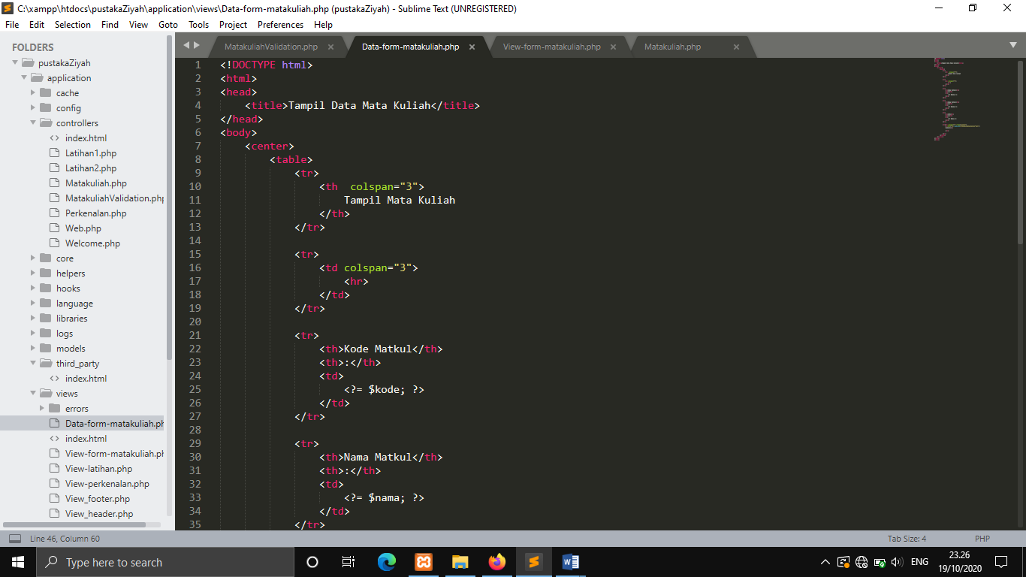

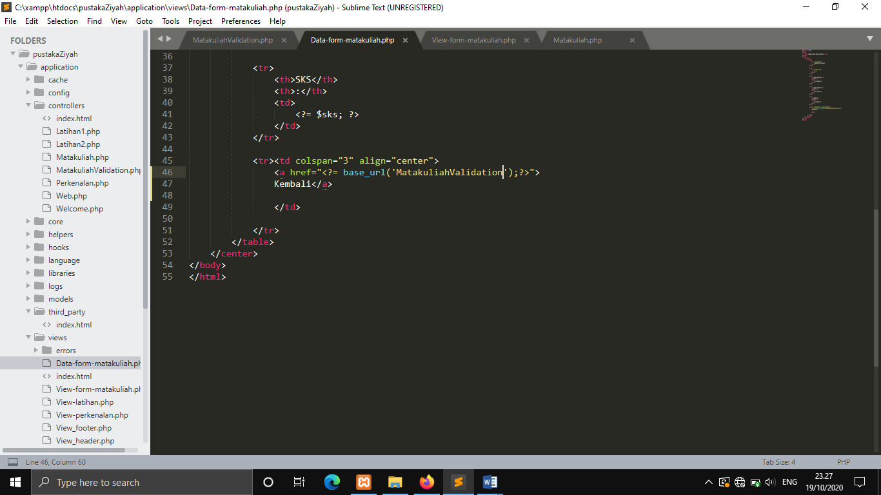

1. URL

<http://localhost/pustakaZiyah/MatakuliahValidation>

<http://localhost/pustakaZiyah/MatakuliahValidation/cetak>

1. Capture Output Program

